

Application

Burundi Mission Trip

Please print or type & attach copy of passport and deposit check

Personal Information (Please Print)
Name (as it appears or will appear on your passport)

________________________________________________________________
Last First Middle
Applicant would prefer to be called: _________________________________________
Address: ______________________________________________________
City:________________________________State: _____Zip:____________
Home phone: (____)___________________
Work phone: (____)___________________
Cell phone: (____)____________________
E-mail: ______________________________________

Medical Information

Health Insurance Provider: _____________________________________________
Policy/Group #: ________________________________________________________
Hospitalization authorization: Phone (_____)________________________
Effective internationally: 􀂆 yes 􀂆 no
Best doctor to contact for consultation:
Name: ________________________________________
Phone: (_____)__________________
Primary policy holder’s name: _____________________________________________

Medical History

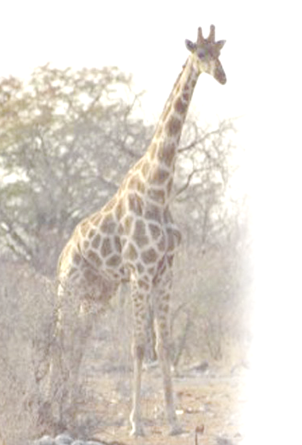
Appraisal of your present health: 􀂆excellent ?good ?fair
Do you have any chronic physical conditions?
?allergies 􀂆asthma ?diabetes ?stomach ailments
heart condition ?other____________________________________
Are you allergic to any medications? ? no ?yes, please list
____________________________________________________________

Will you be taking prescription medications on the trip?
􀂆no ?yes, please list:
1) Type: ________________________________________ Purpose______________________________________
2) Type: _________________________________________
Purpose ______________________________________
Are you on a special diet? ?no ?yes, please explain
________________________________________________________________
Have you suffered from or received treatment for emotional or mental illness? ?no ?yes if yes, please explain: ________________________________________________________________________________________________________________________________
Are you able to:
Climb stairs unassisted? ?no ?yes Lift 25 lbs or more? ?no ?yes

Spiritual Life and Growth

Which best describes you today?
new believer maturing Christian ? discipler/mentor

Do you believe that Jesus is the only way to a relationship with God?
? yes ? no

Team Commitment

If accepted to serve on the Burundi Team, I agree to:
- Attend all team meetings and complete all training required for the team.
- Pray for the team and the mission assignment at regularly scheduled times.
- Continue serving and worshipping regularly with my Church Body.
- Uphold Godly standards of conduct at home and on the field.
- Minister with sensitivity and respect for the cultural differences of the country in which we are serving.
- Serve in unity.
- Lead as a servant, placing the needs of the team above my own.
- Submit to leadership authority.
- Organize local prayer warriors who will pray for me for a season of time before, during and after the ministry assignment.
- If married, participate on the team only with my spouse’s blessing.
- Raise my financial support beyond what I already give in tithe to my church, without going into debt.

Dates of Trip: August 30 – September 12 Duration: 14 days

The Trip cost is: approximately $2500 + airfare

Deposit: A non-refundable deposit of $300 is due by June 1st.

Balance Due: The remaining amount is due by July 16th.

I have read the above info and agree with it.

_____________________________________________________________
Applicant signature Date
Email application to: Jerimatson@gmail.com
FOR OFFICE STAFF ONLY | Date
Received $300 Non-refundable Deposit
Received Application
Received Balance of trip costs
Received Release Disclaimer
Received Authorization For Medical Treatment

